**Abstract**

1. **Introduction**

Audio data analysis is a fascinating field that delves into the intricate world of sound, transforming raw acoustic signals into meaningful insights. From speech recognition and music information retrieval to environmental sound monitoring and medical diagnostics, the ability to effectively analyse audio is crucial across numerous disciplines. At its core, audio data exists as a wave signal, a continuous representation of pressure variations over time. However, directly interpreting complex wave signals can be challenging due to their inherent temporal nature.

To unlock the rich information embedded within these signals, a powerful set of mathematical tools known as the Fourier Transform and its various derivatives come into play. The fundamental idea behind the Fourier Transform is to decompose a signal from its time-domain representation into its constituent frequencies, revealing the underlying spectral components that define the sound. This transformation allows us to understand not just when a sound occurs, but also what frequencies are present and at what intensity.

This introduction will explore the foundational concepts of audio data analysis, focusing on the characteristics of wave signals and the indispensable role of the Fourier Transform family, including the Fast Fourier Transform (FFT) and the Short-Time Fourier Transform (STFT). By understanding how these techniques allow us to transition between the time and frequency domains, we can effectively extract features, identify patterns, and ultimately gain a deeper comprehension of the complex auditory world around us.

**Literature review**

This is the part for literature review

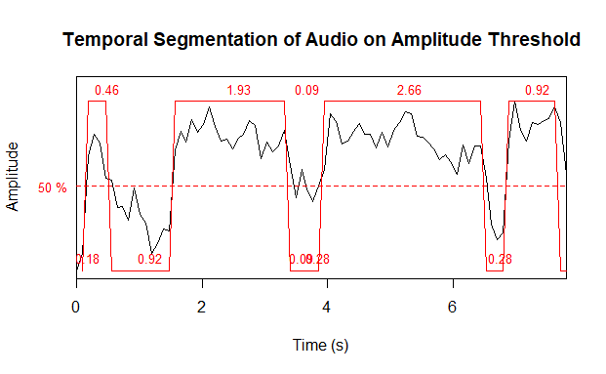

Figure 1 Timer plot of Lion's Roar

**Methodology**

Two audio recordings were analysed which are one of a lion roaring and one of a human male crying. The signals were captured at standard sampling rates of 44,100 Hz and stored as digital waveforms, prior to analysis, each waveform was normalized and detrended to remove any DC offset or linear trend. No additional noise filtering was applied, as the signals were presumed to be relatively clean.

We first performed temporal segmentation to isolate vocal events from silence or background noise, we used a simple amplitude-threshold method.

**Results and Discussion**

* 1. *Timer plot*

The segmentation results from figure 1 and 2 highlight clear differences between the signals. The lion’s roar consists of a few long-duration pulse (

* 1. *Frequency Domain Analysis*

The spectrograms reveal distinct spectral profiles. In the lion roar spectrogram (Figure 3), we observe prominent low-frequency energy. The fundamental frequency appears to be on the order of a few hundred hertz:

* 1. *Frequency Domain Analysis*

**Conclusion**

This comparative analysis demonstrates clear acoustic distinction between a lion’s roar and a human cry. Methodologically, we showed how simple amplitude-threshold segmentation coupled with FFT and spectrogram analysis can isolate and characterize such vocalizations. The lion’s roar exhibited long-duration pulses with a low fundamental frequency and strong harmonic formants.

**References**

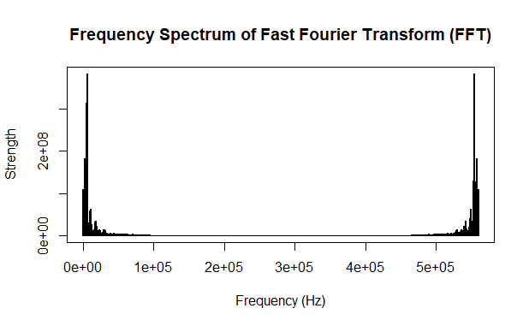

Figure 2 Frequency Spectrum of Lion Roar

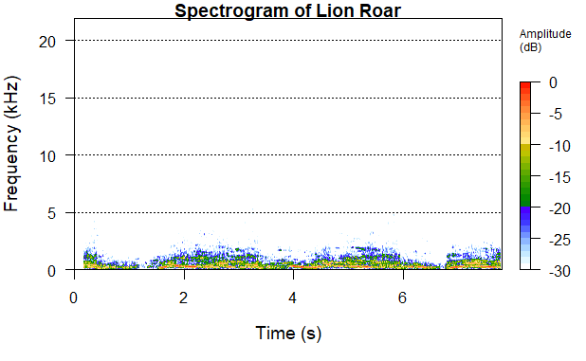

Figure 3 Spectogram of Lion's Roar

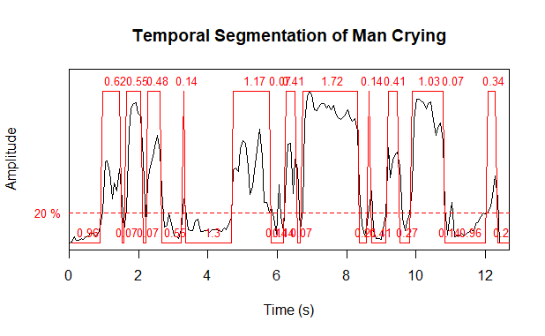

Figure 4 Timer Plot of a man's crying